AWS Lambda,AWS API Gateway & AWS KMS

“AWS Lambda is a serverless compute service. It helps developers run applications without provisioning or managing servers. AWS automatically handles scaling, availability, and infrastructure. Lambda works based on events like S3 uploads or API requests. It is mainly used for automation, backend APIs, and real-time processing.”
Create a Lambda function that returns a simple JSON response.
- Open Lambda in AWS console
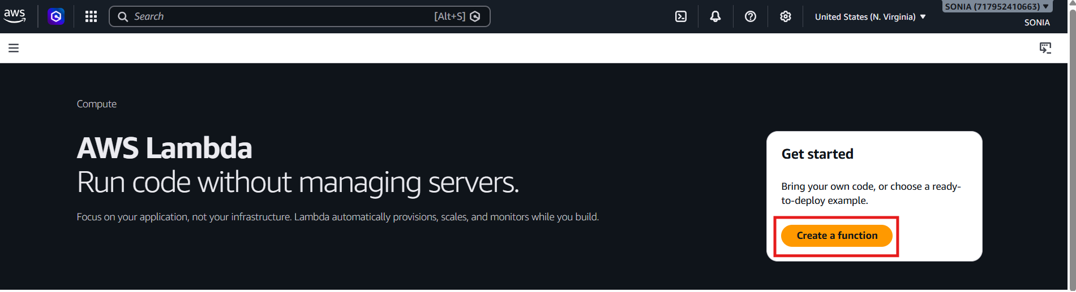
Create Lambda Function
Click on create function Select Author from scratch Function Name
Choose Runtime → Architecture → Click Create Function

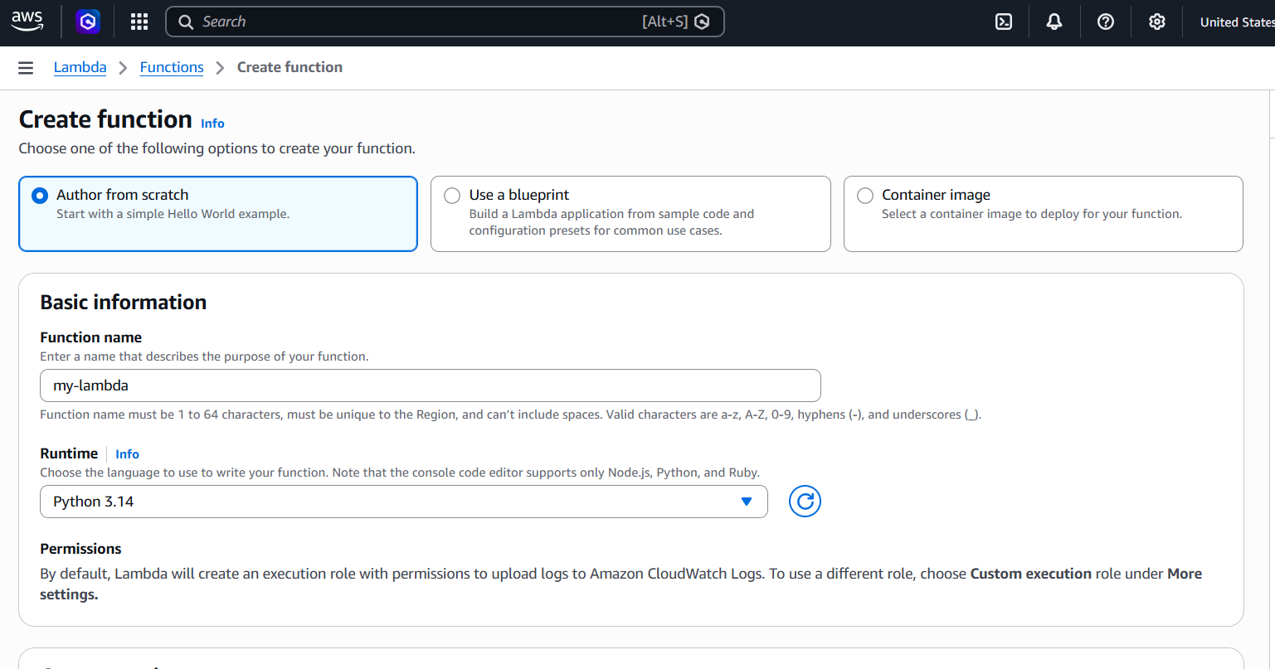
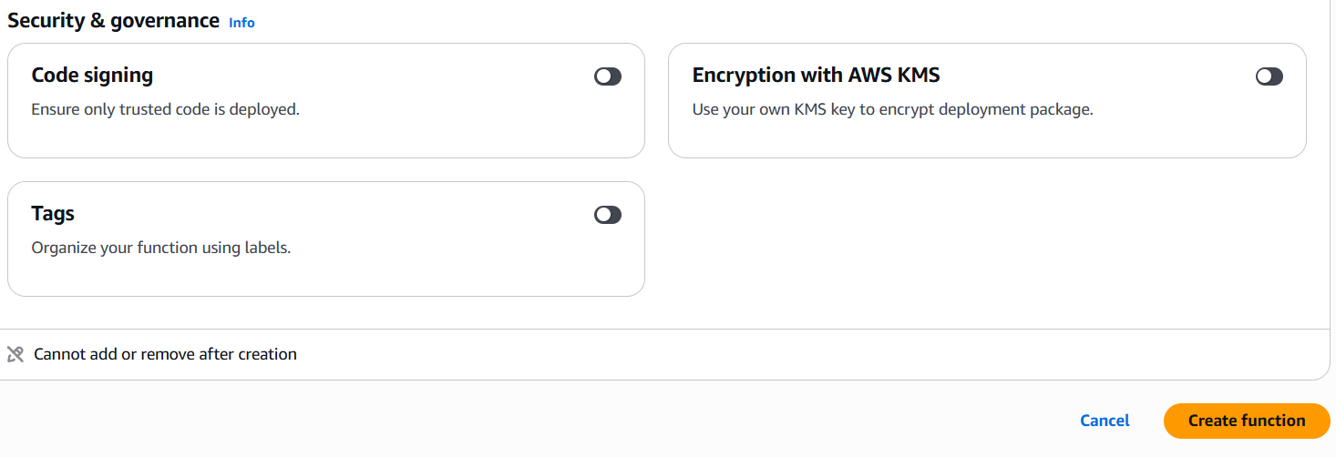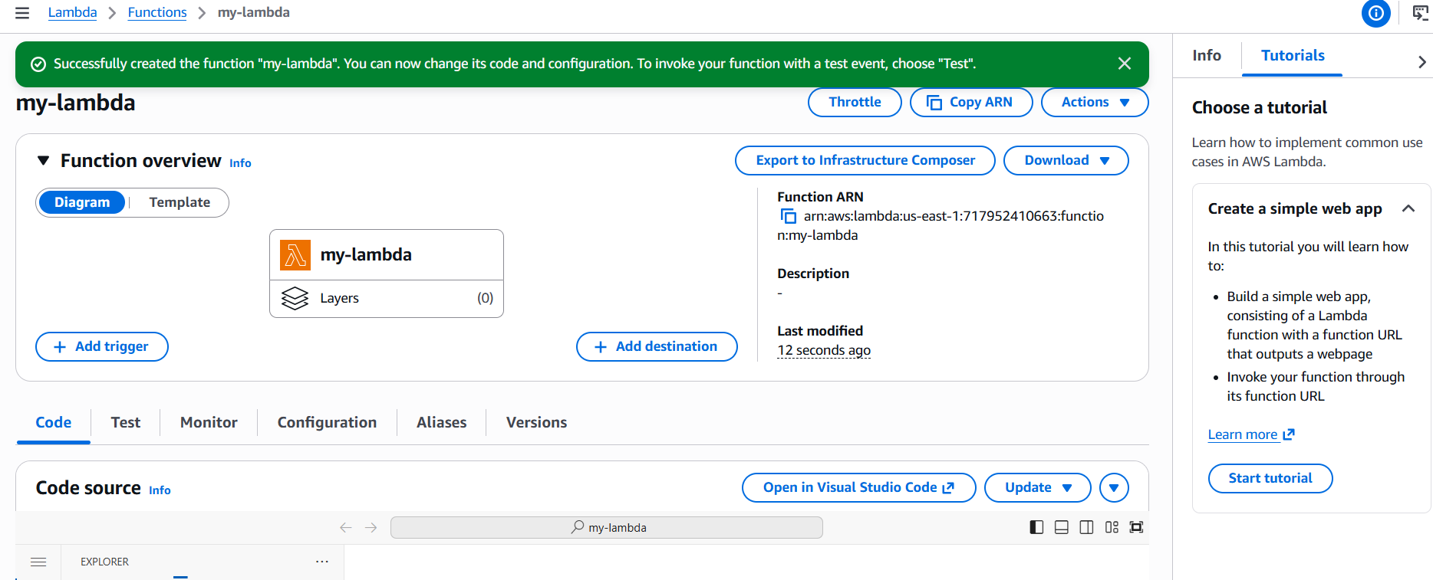
- Add Lambda code and click on deploy
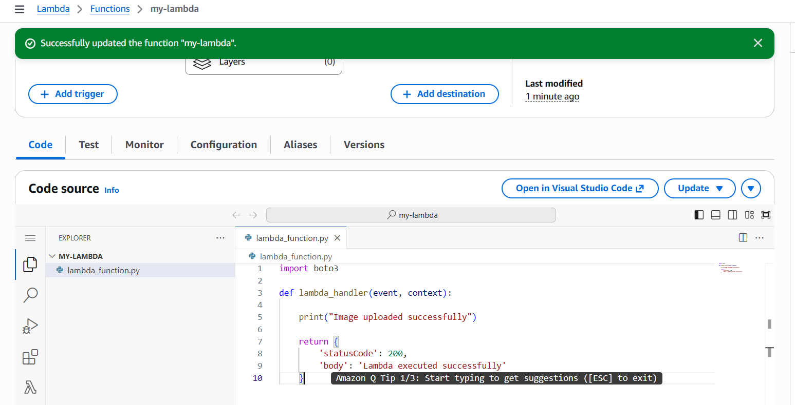
Test Lambda Function
Click test -create test event

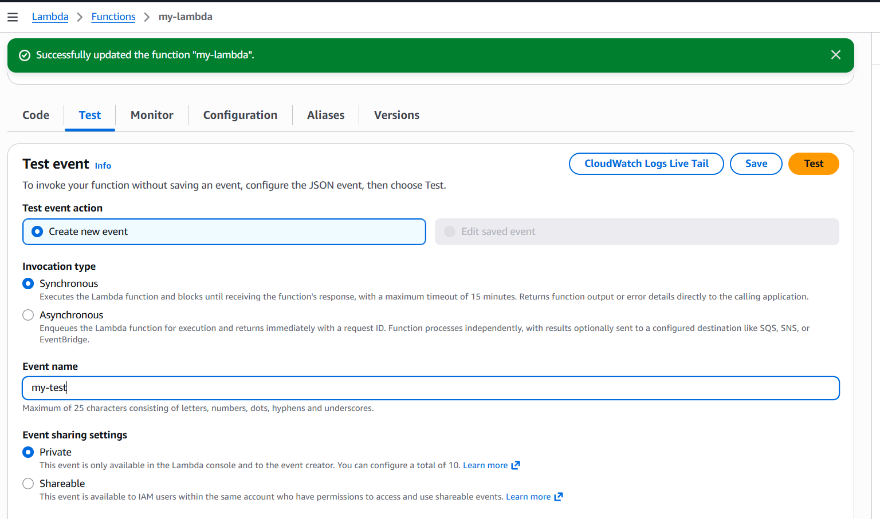
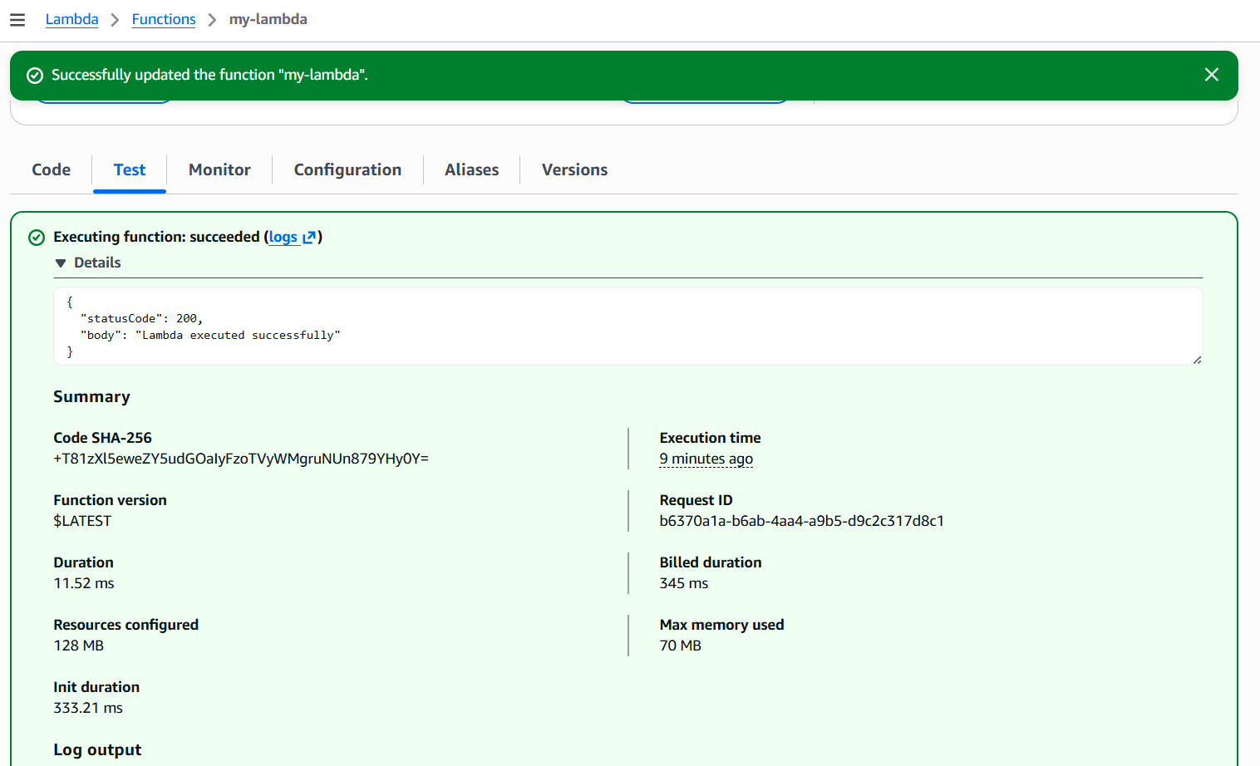
Use Case : Create an AWS Lambda function that automatically runs
whenever a file is uploaded to an S3 bucket and prints the uploaded file
name in CloudWatch Logs.
- First lets create an S3 bucket
Click Create Bucket Bucket Name Click Create Bucket
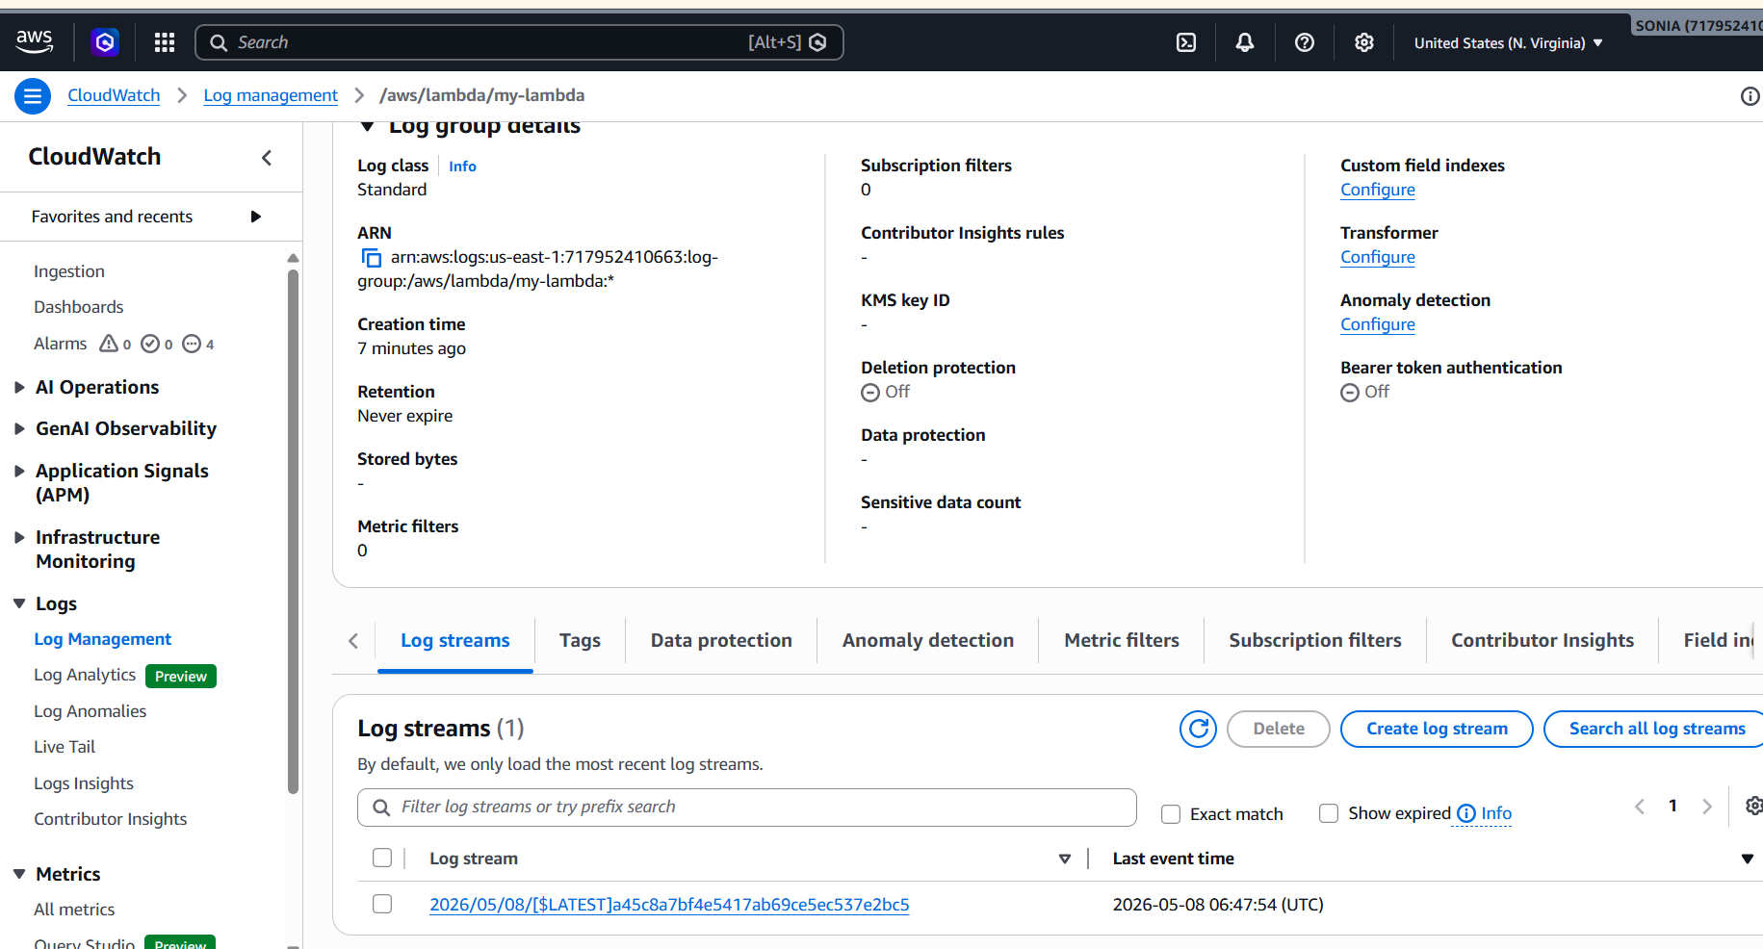
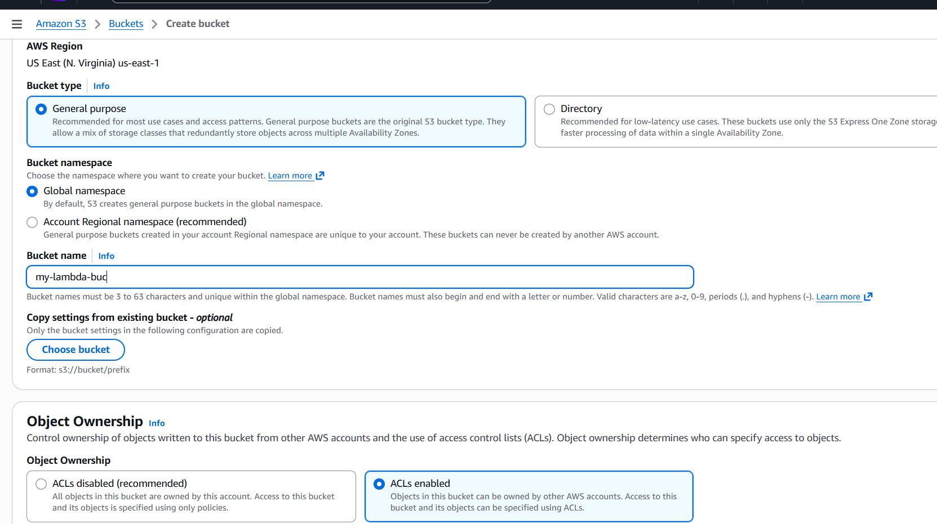
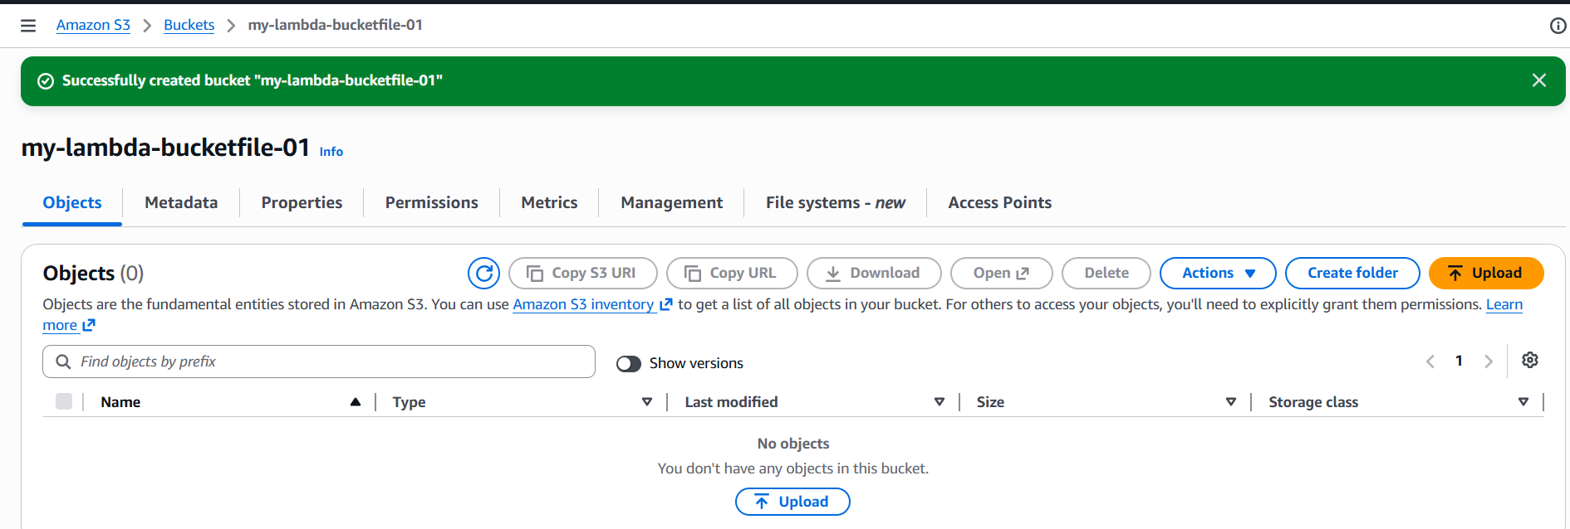
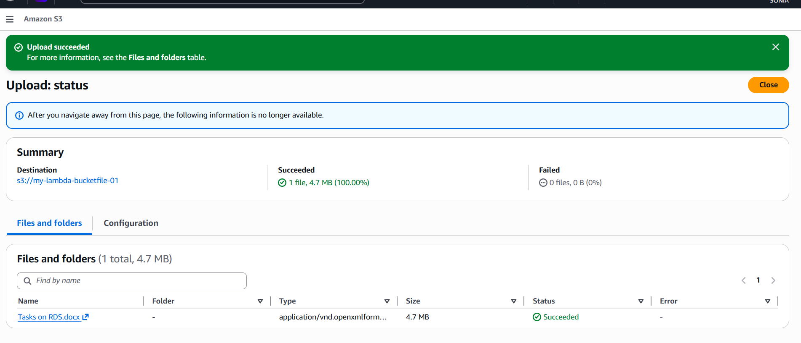
Create Lambda Function
Click Create Function → Select Author from scratch → give Function Name →
Choose runtime → Click Create Function
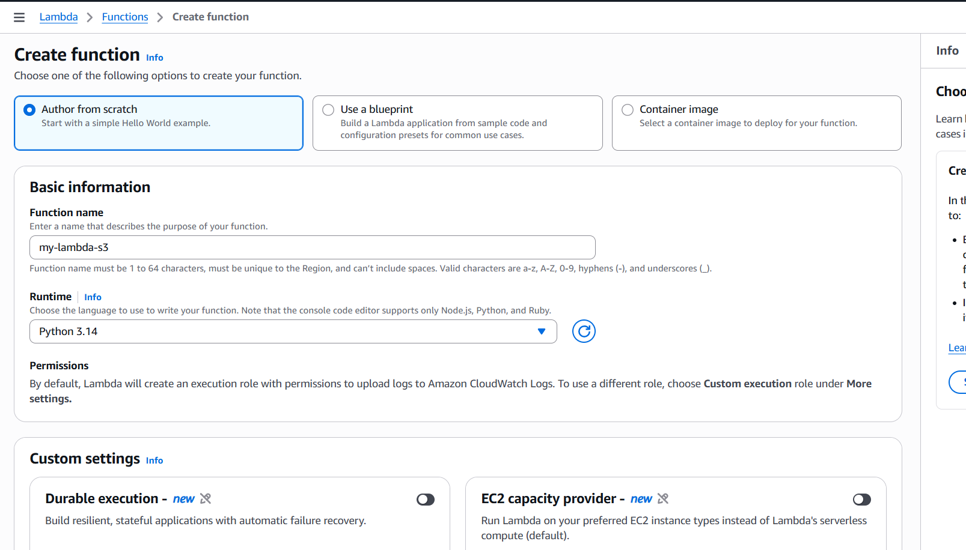
Add lambda code and deploy
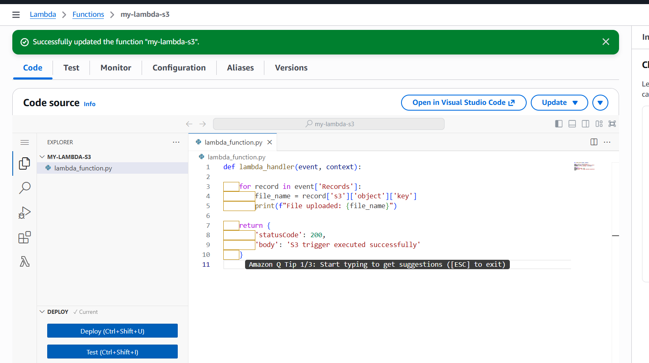
Add S3 Trigger
Click Add Trigger Select source: S3 Choose bucket Event type: PUT (Object
Created) Enable trigger Click Add
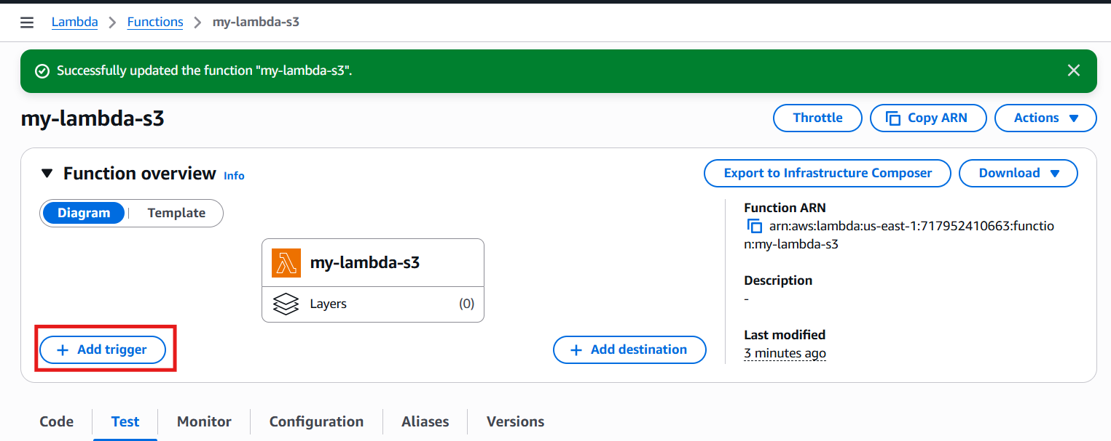
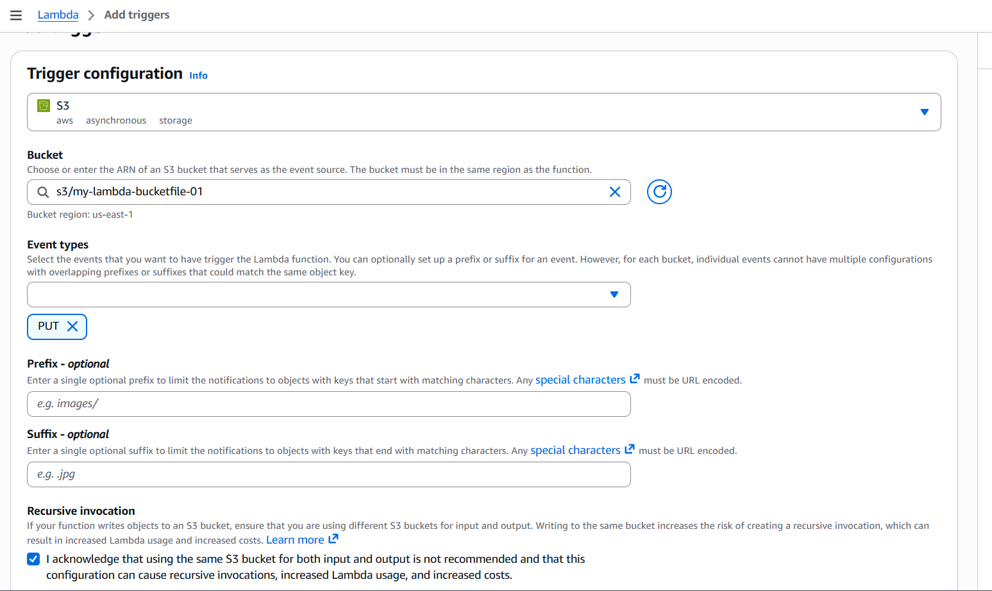
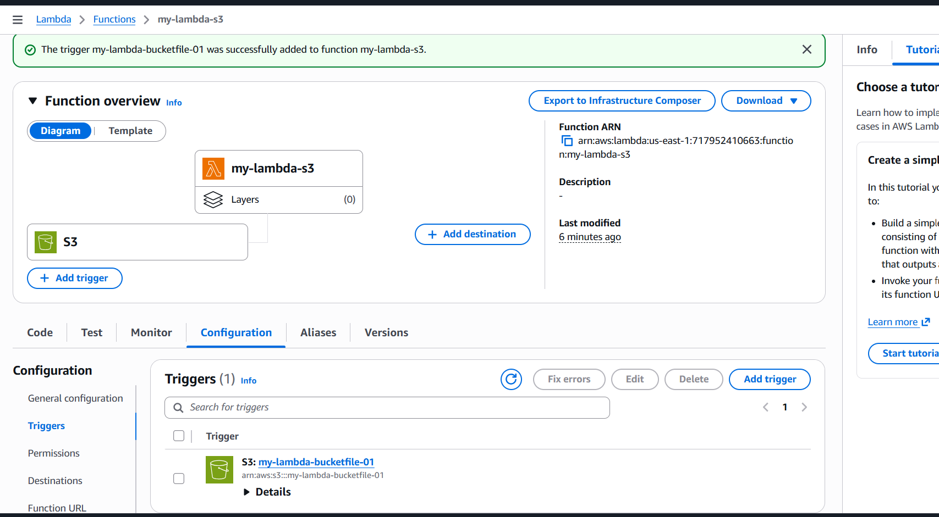
Upload file in S3 bucket
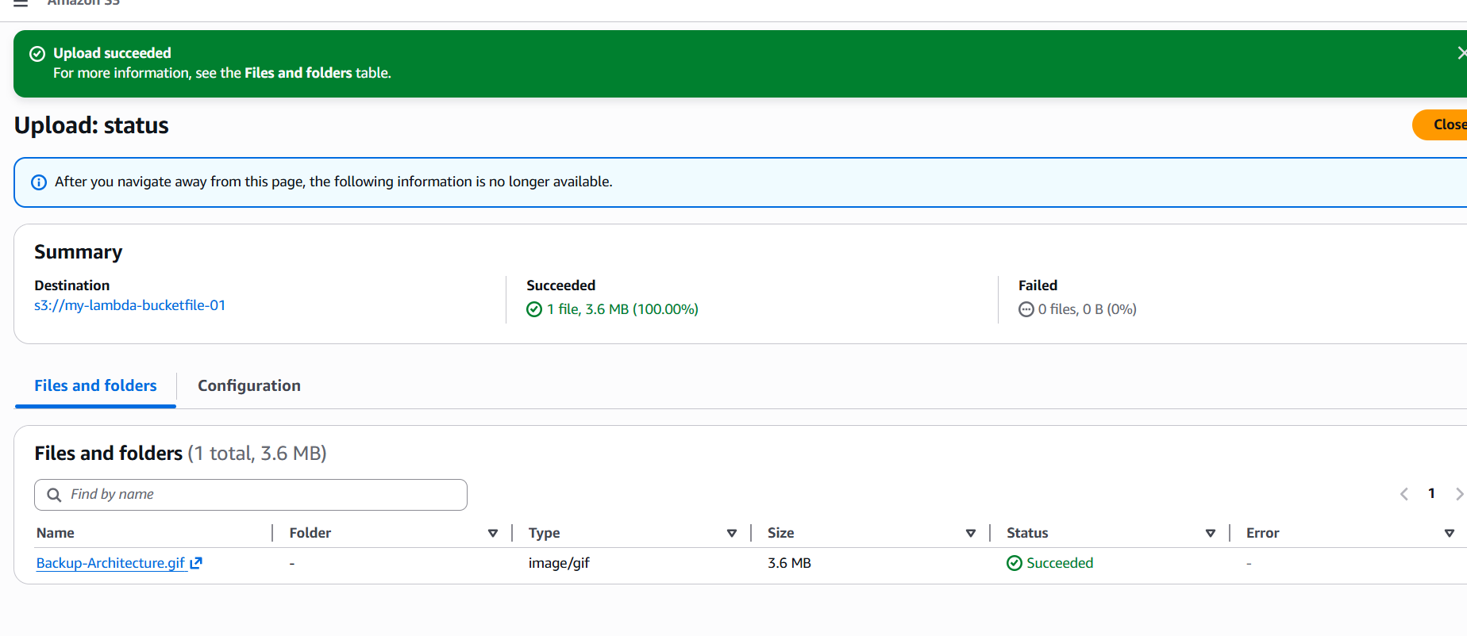
Go to aws lambda click on monitor view cloudwatch logs
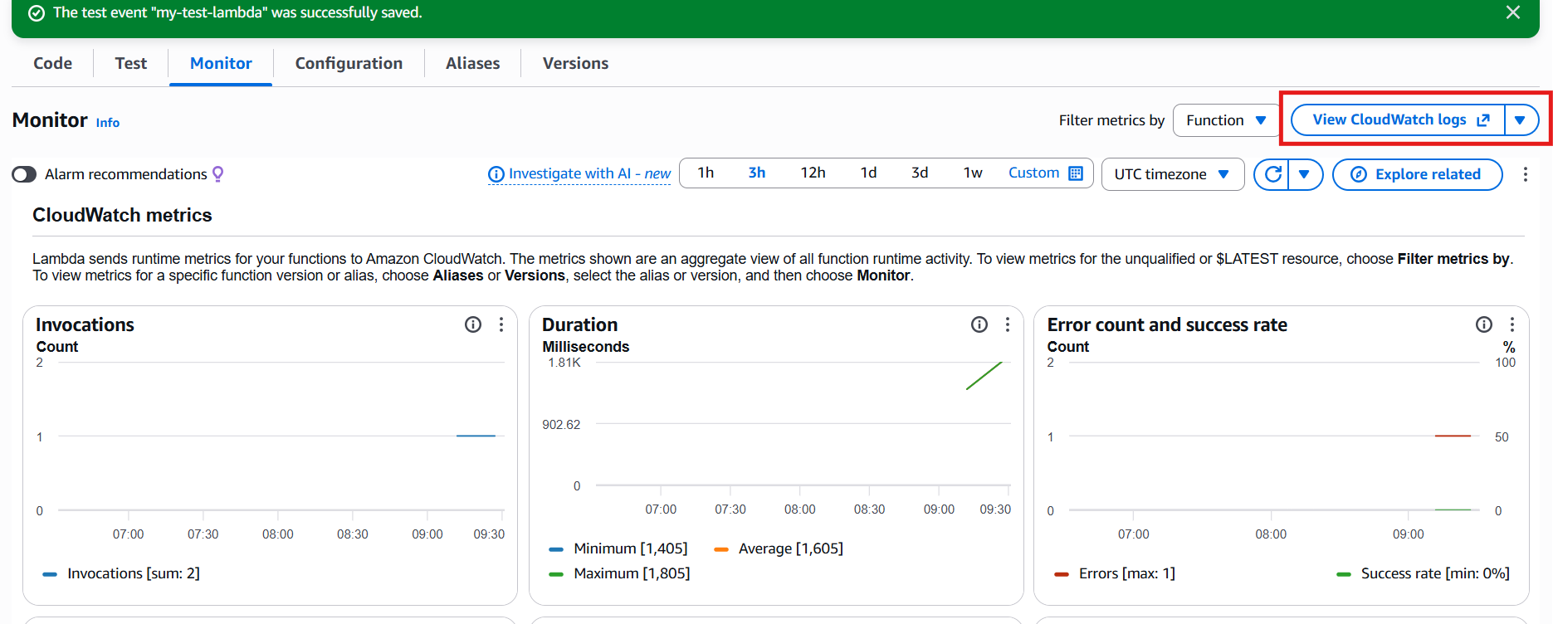
Here we are able to see the log of uploaded file
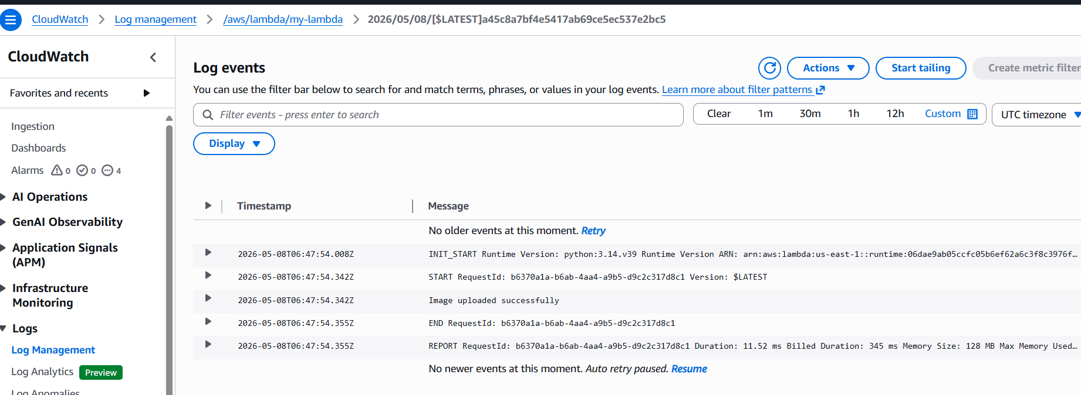

Api gateway
Amazon API Gateway is a fully managed AWS service used to create, publish, maintain, monitor, and secure APIs at any scale.
API Gateway helps developers create APIs so applications can communicate securely with backend services.
User API Gateway Lambda Response
Click create an API click on Build REST API give
API Name endpoint type create API
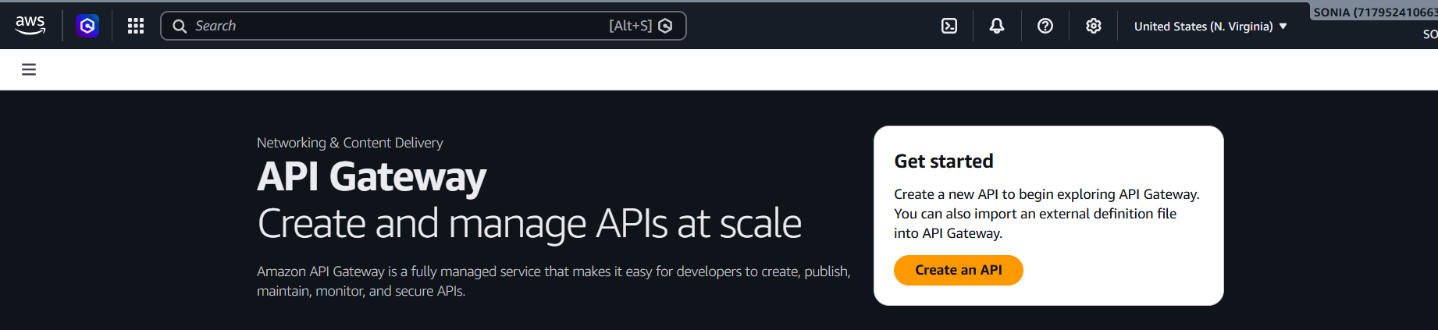
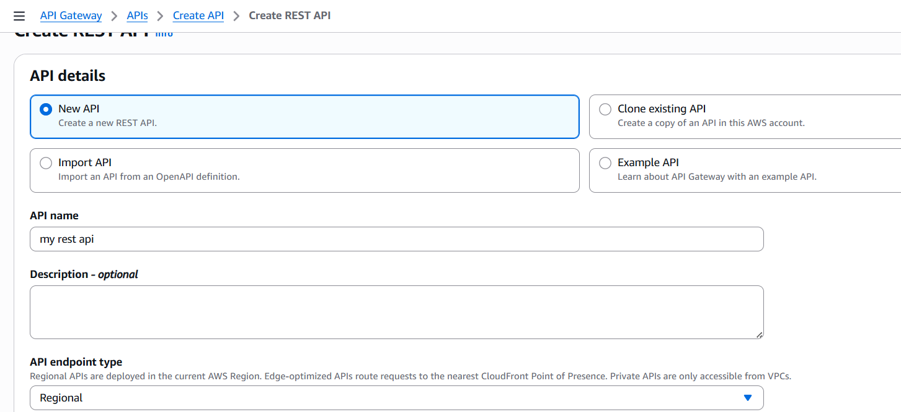
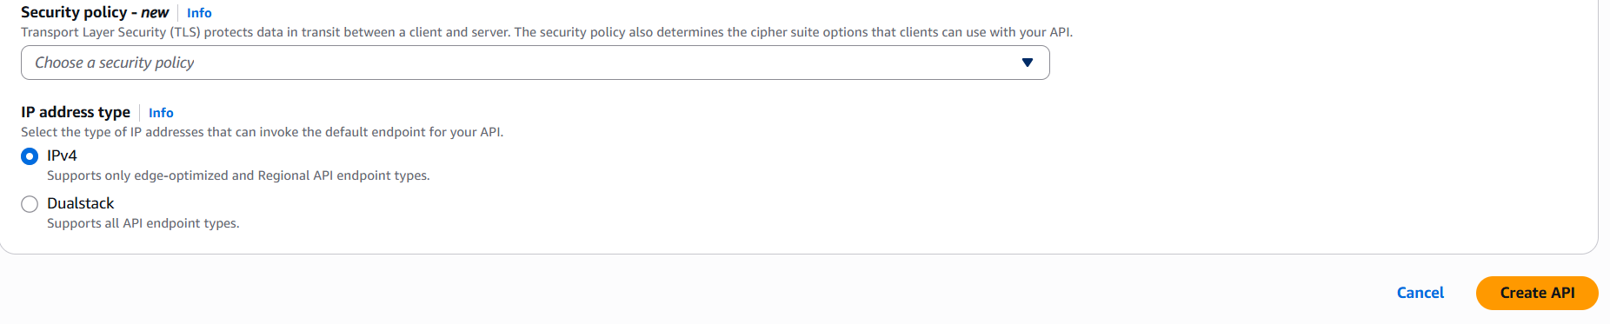
Create Resource :
Click Create Resource give Resource Name give
resource path click create resource
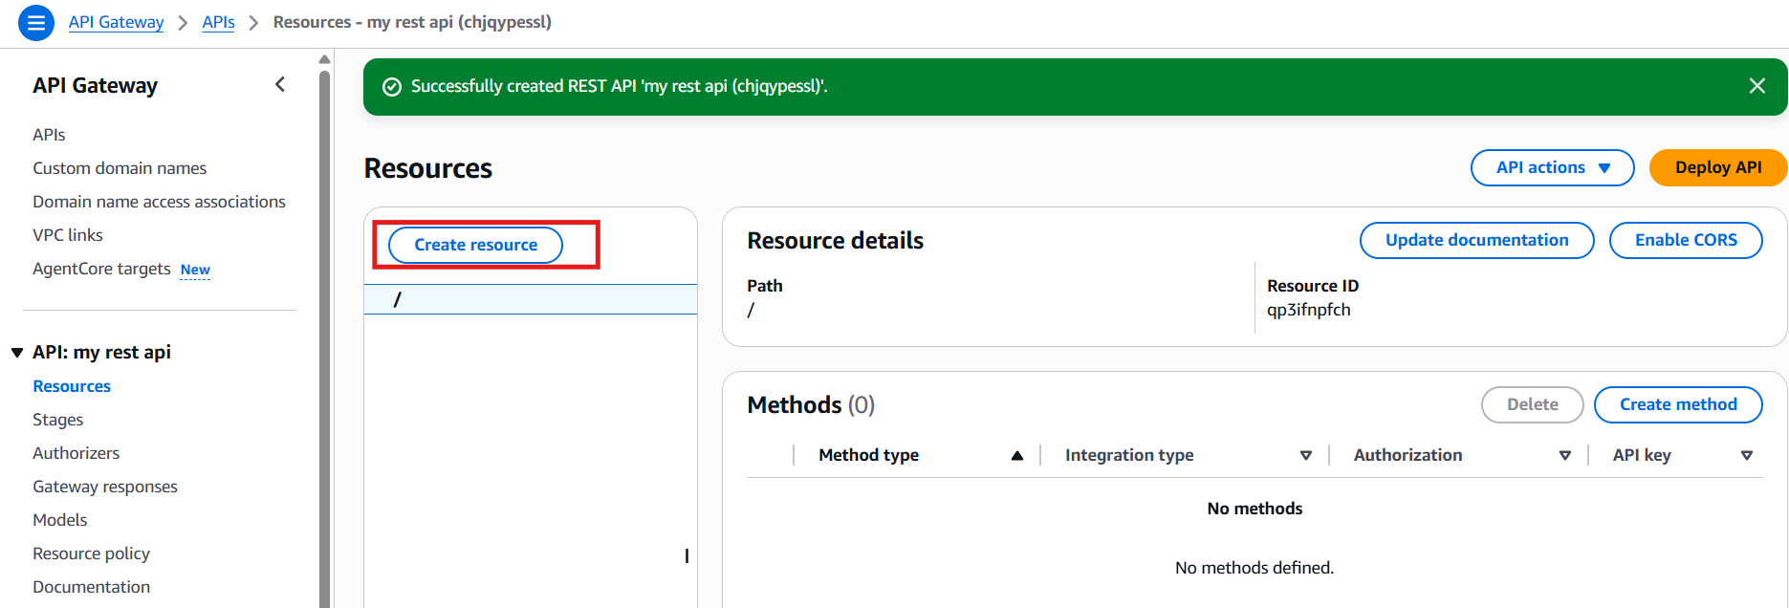
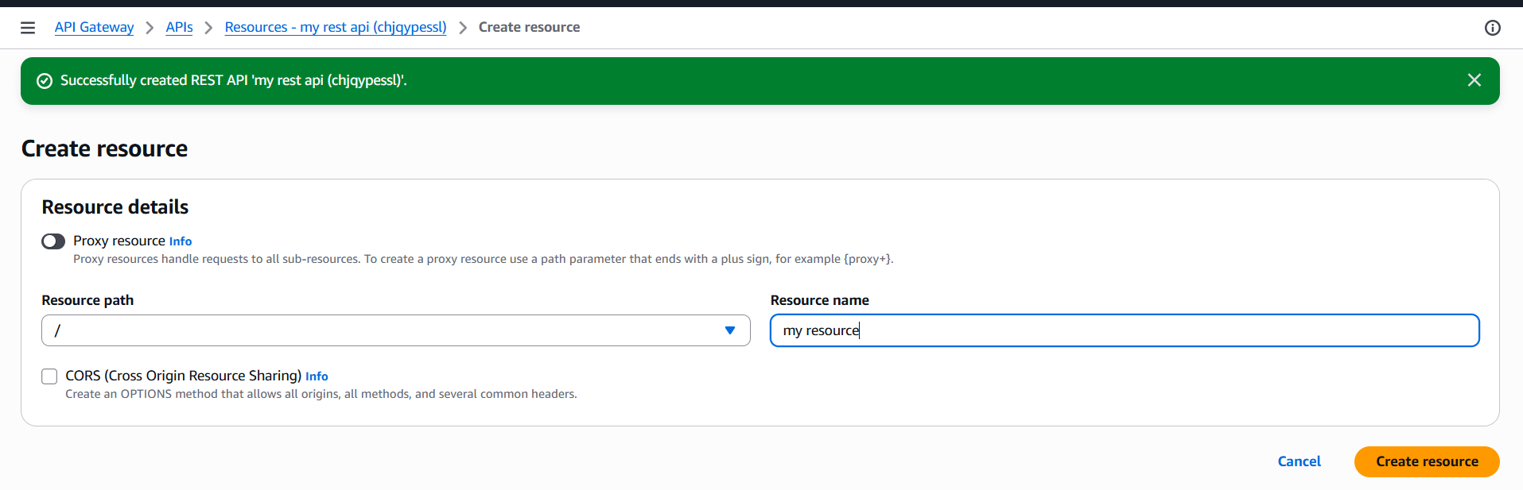
Create GET Method
Select / Click Create Method Method Type :GET Integration Type:Lambda
Function Enable Lambda Proxy Integration Enter Lambda Function Click
Create Method
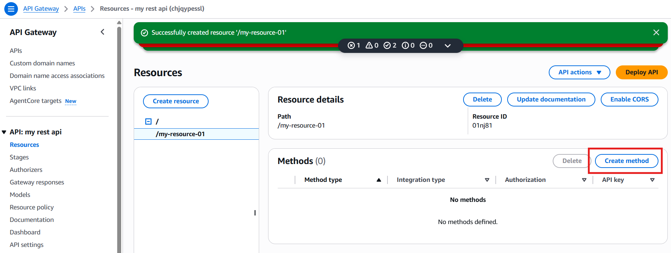
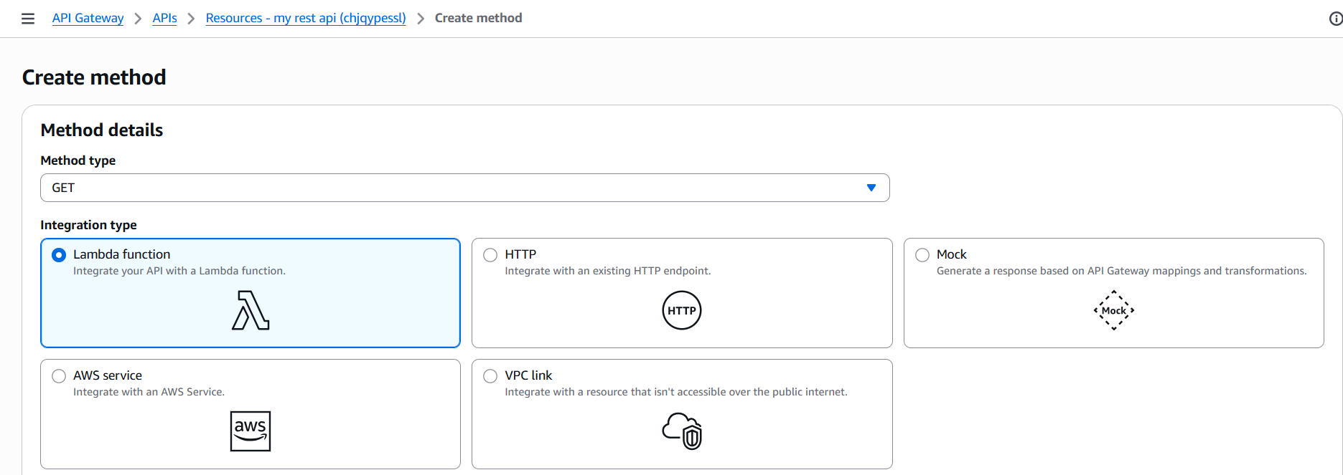
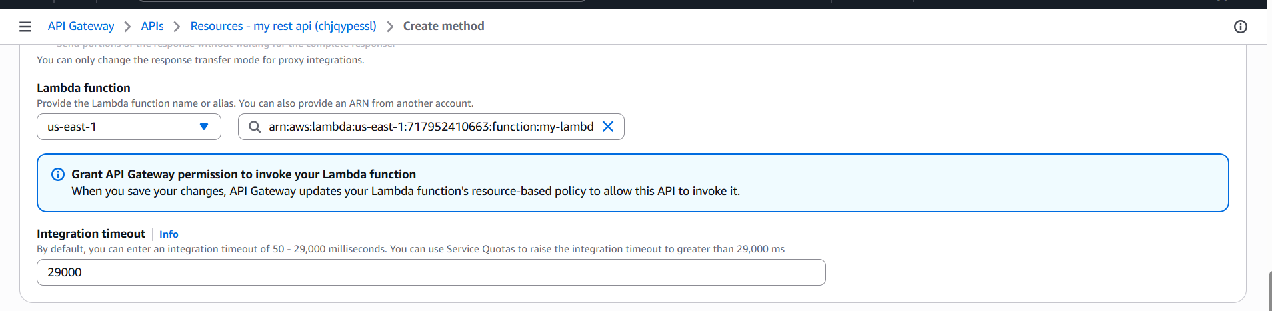

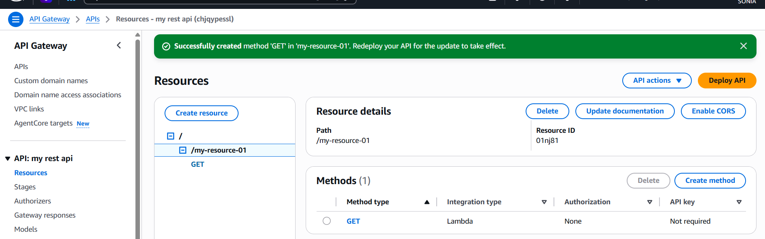
Deploy API
Click deploy API Stage name Click Deploy
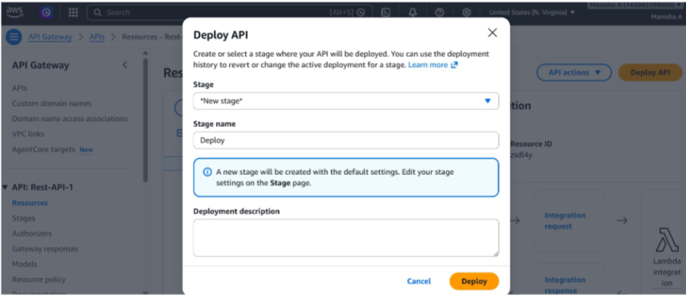
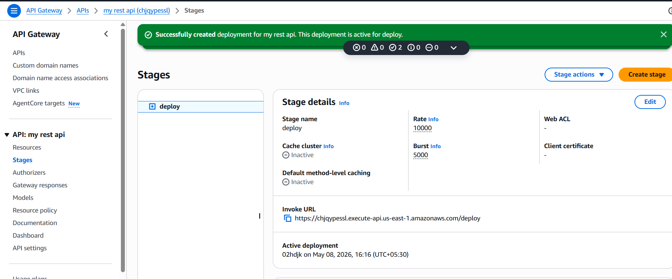
I have checked in browser and it worked finess
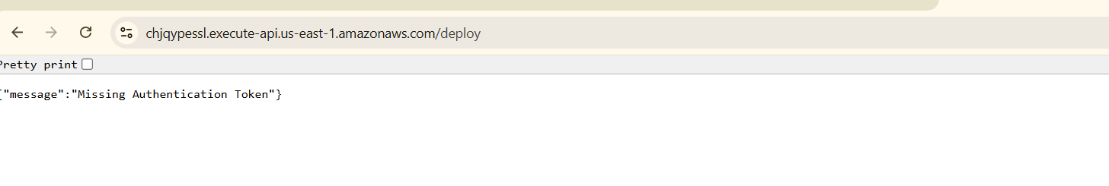

Aws-kms
AWS KMS (Key Management Service) is a fully managed encryption service
provided by Amazon Web Services that allows users to create, manage, and
control cryptographic keys used to secure data. It integrates with multiple AWS
services and helps protect sensitive information by enabling encryption,
decryption, and access control.
USE CASE :
A company stores customer financial documents in an S3 bucket. To ensure
sensitive customer data is protected, the organization uses AWS KMS to
encrypt files before storing them in S3. Only authorized IAM users and
applications are allowed to decrypt and access the files.
Create KMS Key
Click on create key Key Type: Symmetric Key Usage: Encrypt and Decrypt
Alias Click Create Key
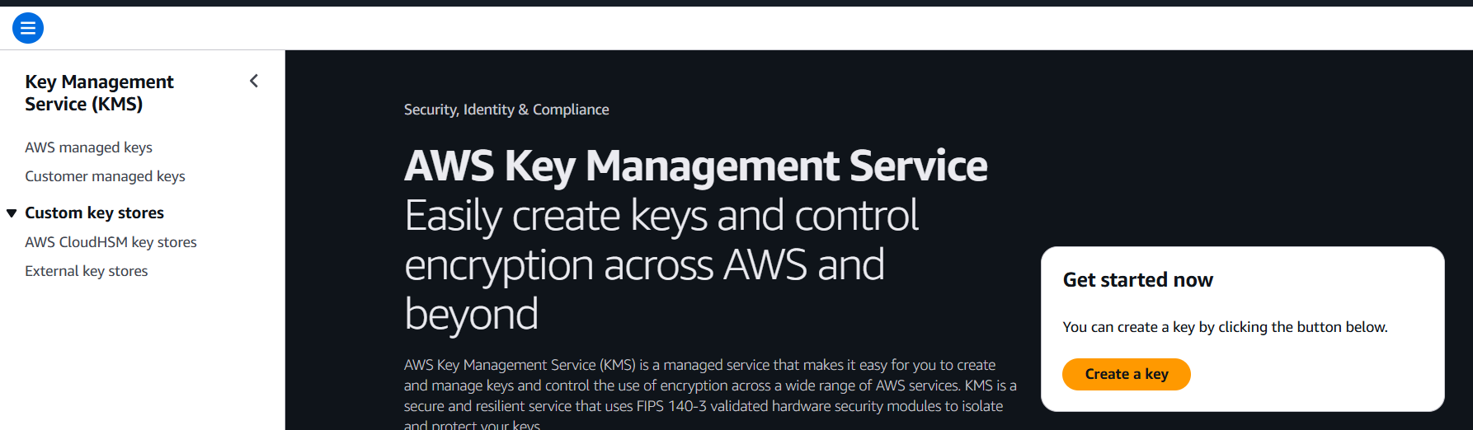
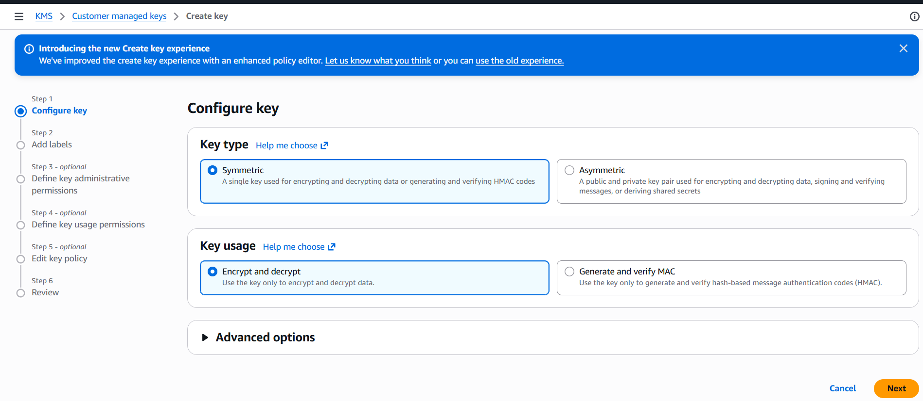
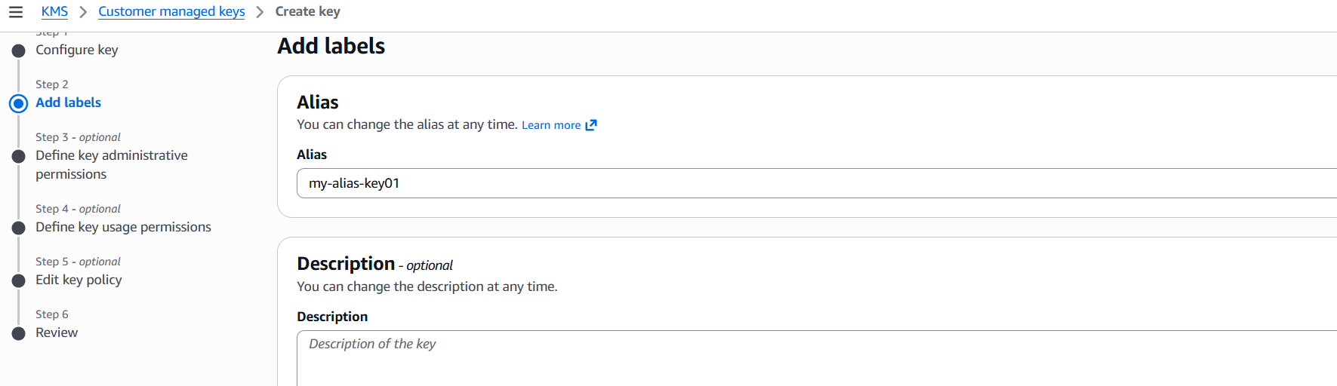
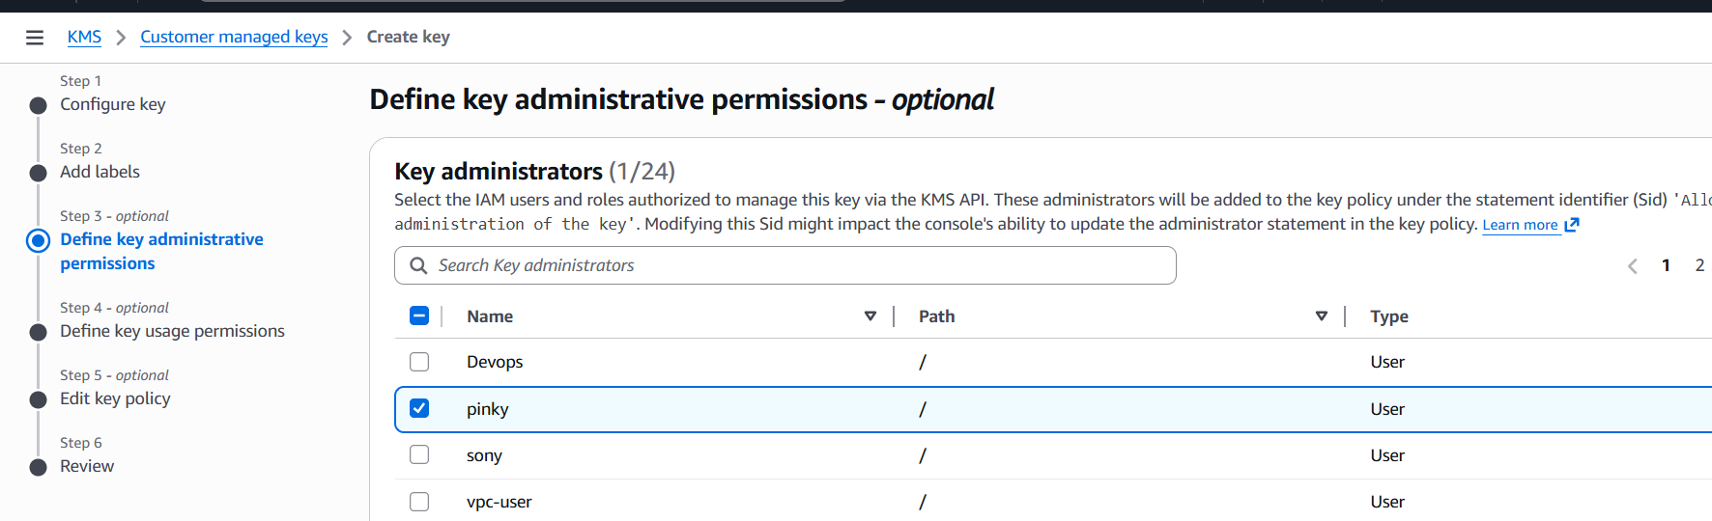
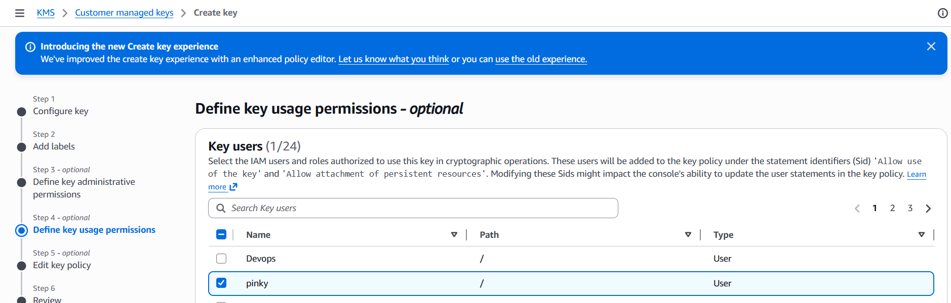
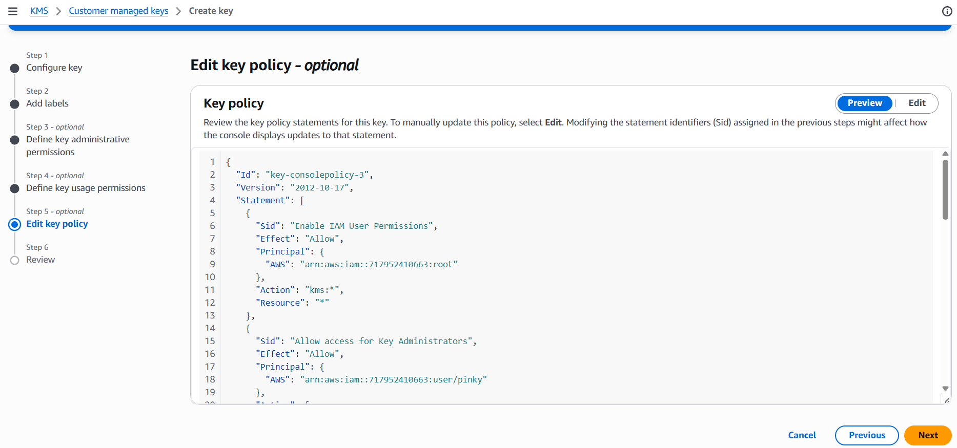
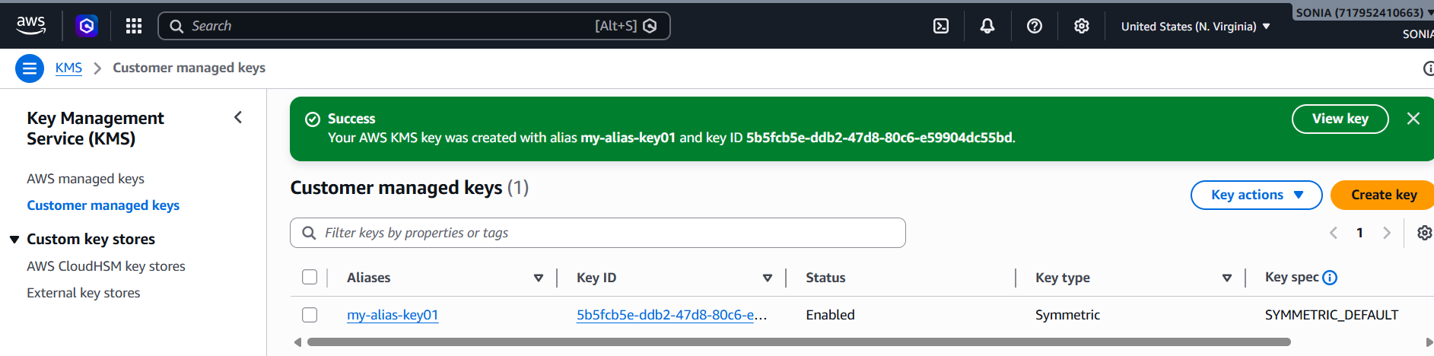
Create S3 bucket
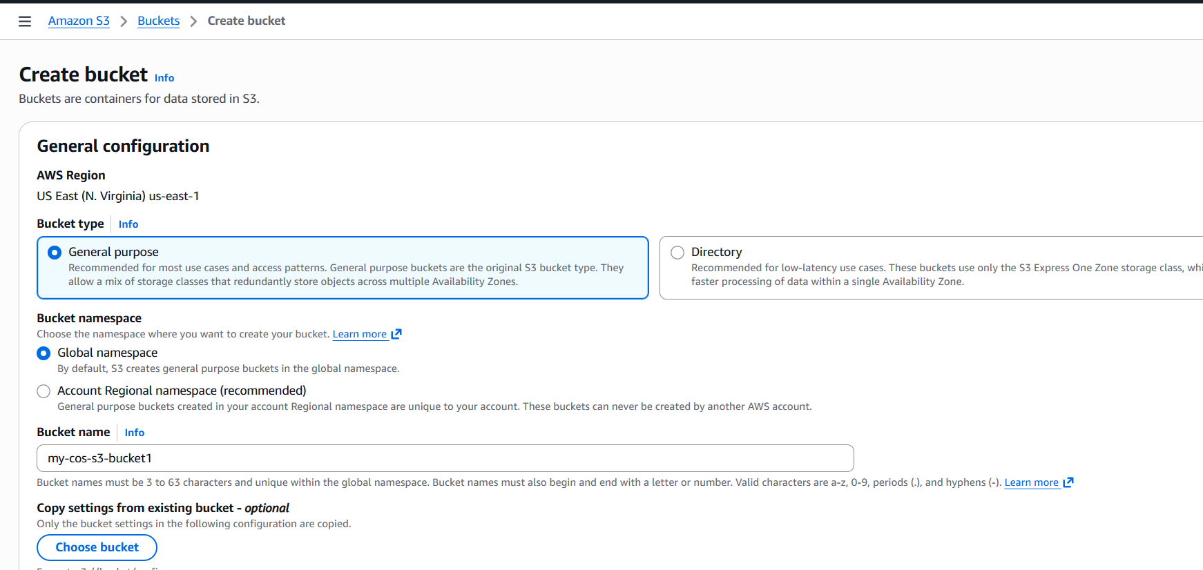
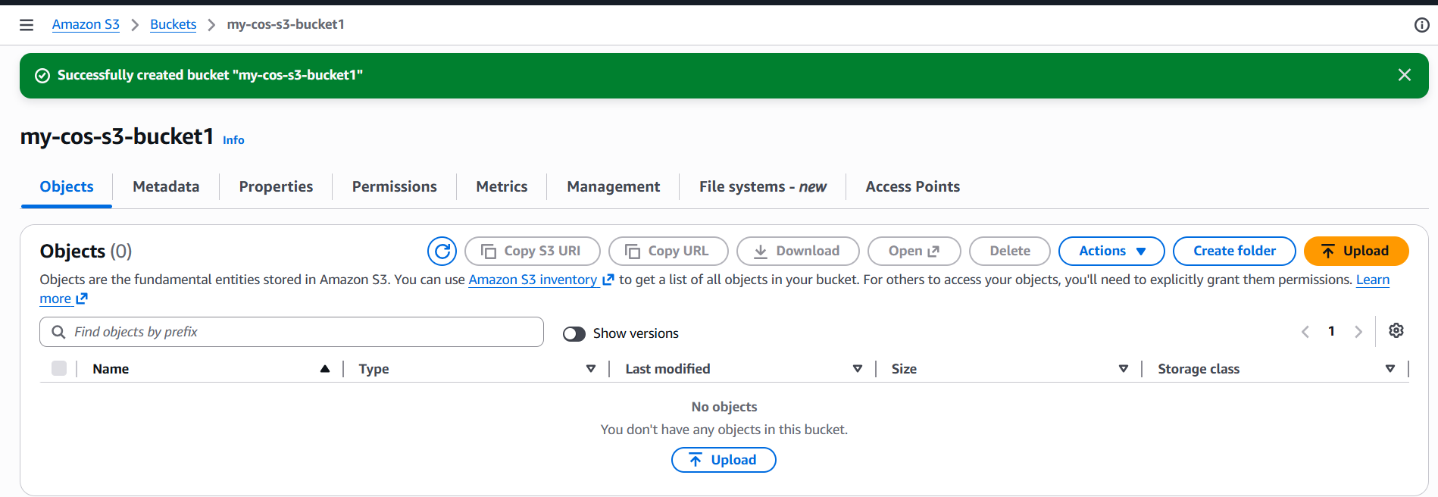
Enable KMS Encryption on S3 Bucket
Go to Property Scroll to default encryption click edit enable server-side
encryption choose aws kms select KMS key save changes
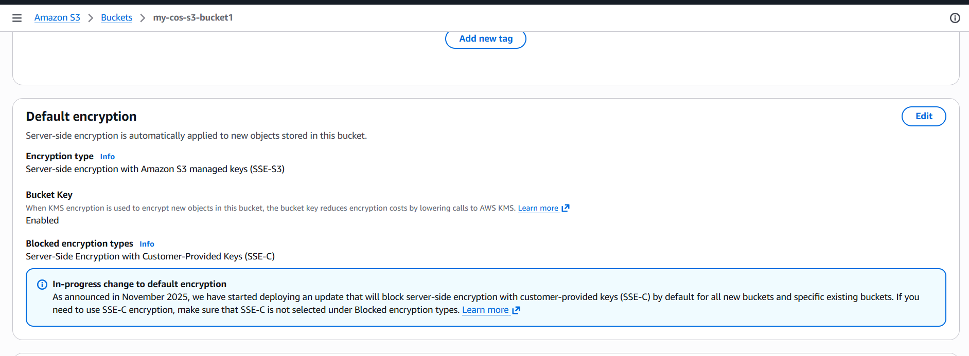
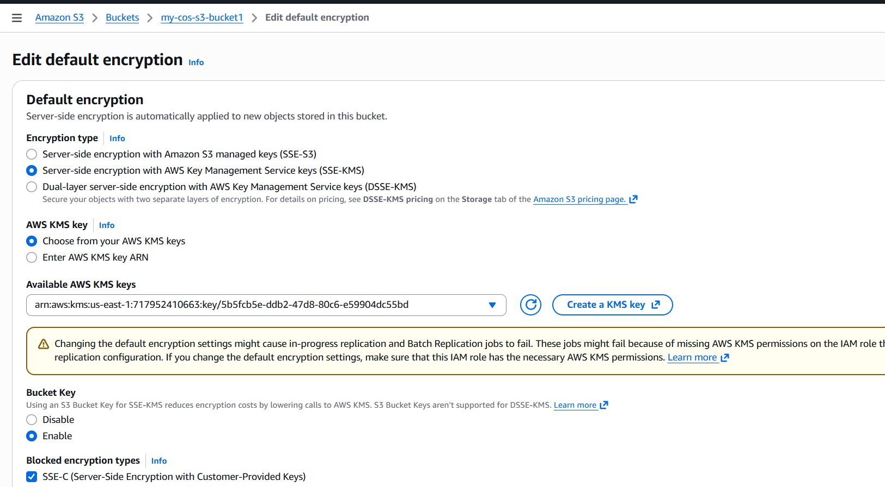
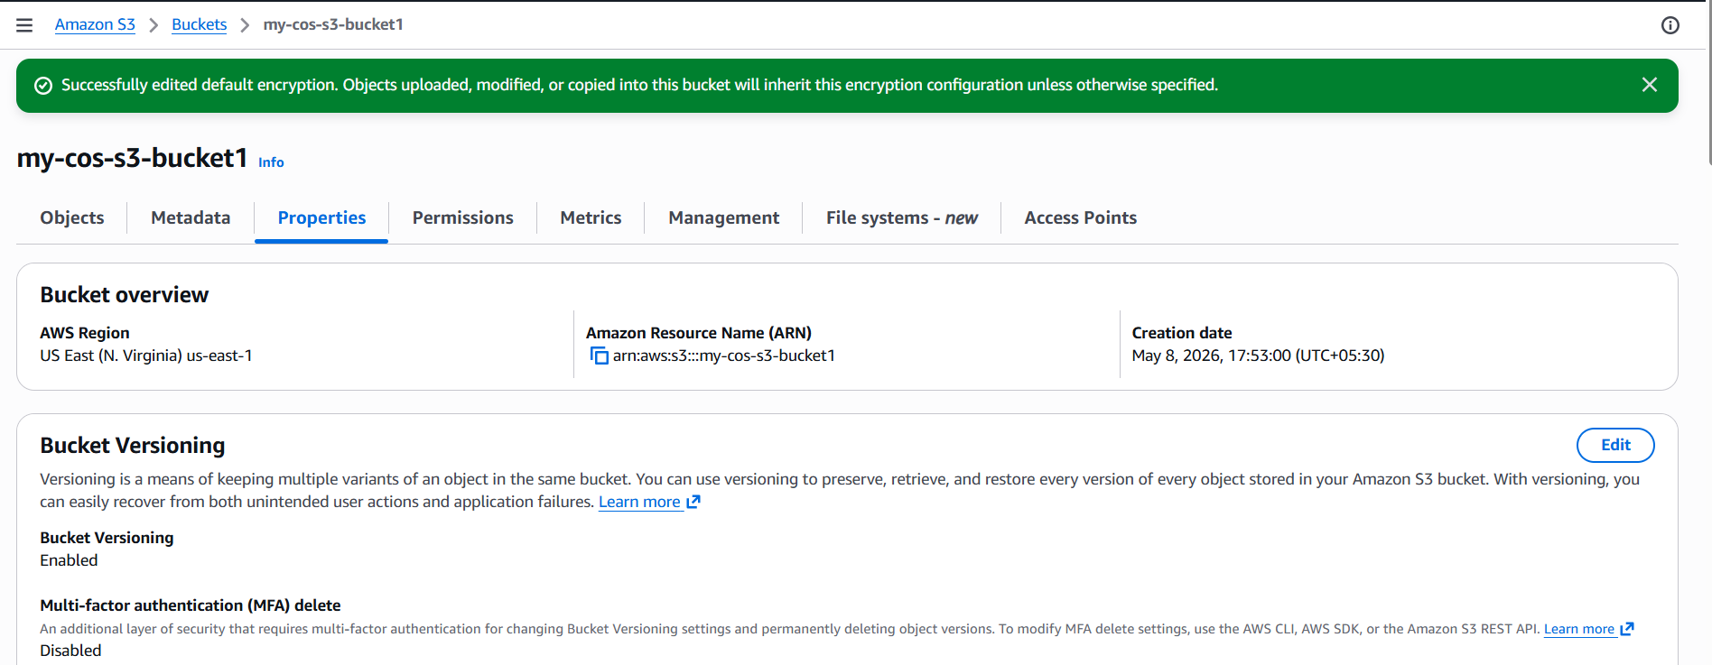
Upload a doc in s3 bucket
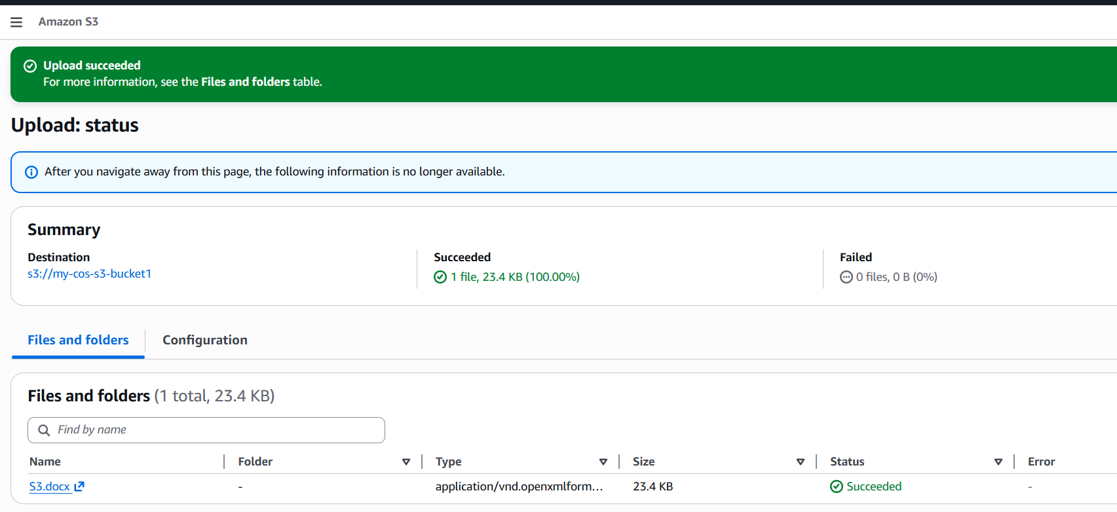
To verify
Go to s3 object → properties → we can see encryption key ARN
